Employee Self-Service is being Upgraded

On Feb 12th between 8 am - Noon, ISU will be upgrading the Employee Self-Service module found in the ISU portal.
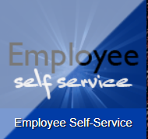
With the new version the navigational paths to your data has been condensed into two main paths.
- Employee Dashboard
  - You can review
    - Leave Balances
    - Earnings
    - Benefits
    - Taxes
    - Job Summary
    - Enter/Approve Leave Reports
- My Profile
  - Personal Information – you can review and update the following information.
    - Address
    - Phone
    - Email
    - Emergency Contact Information,
  - Direct Deposit – you can view and update your Direct Deposit information

Please login and become familiar with the navigation to your data. If you have questions please call the Human Resources Office at ext. 4114 .

